Please place this photo with the caption underneath at the very top of the English subject page.
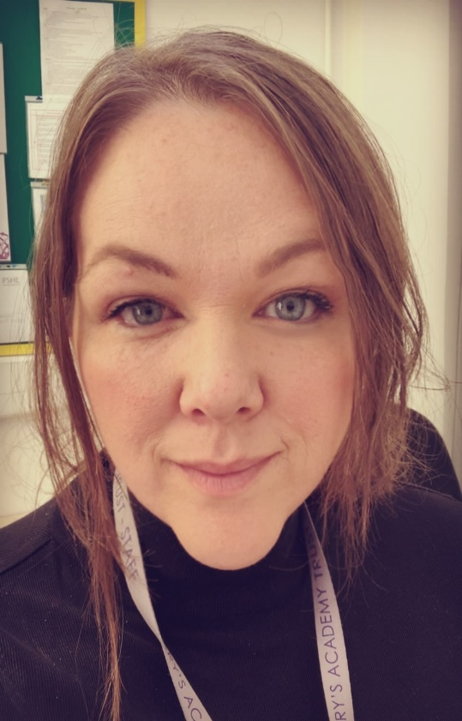

Our English subject leader is Mrs Fox.

Then please put this text underneath:
“The ability to communicate is one of the most essential life skills. By speaking, listening, reading and writing, you can express your amazing ideas and learn about the ideas of others. During your time at Queens Road, you will be taken on many exciting adventures through our English curriculum. How magical!”

Then is it possible to have 3 separate ‘button/links’ titled Reading and Phonics, Writing, Oracy which will take them to 3 different places when pressed? Something like this below.

Writing
Reading & Phonics
Oracy
Then all of those boxes with photos and text can stay where they are and I’ll send across some more up to date ones.
I’ll send over separately the stuff to go on the ‘Writing, Reading & Phonics, Oracy’ pages separately.

