Date Given:  21.04.20 | Spelling Rule:  Words with the short /u/ sound spelt with ‘ou’

Complete the task below.
Test Words
young | rough
touch | tough
double | cousin
trouble | eight
country | continue
courage | different

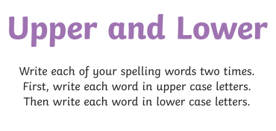

Then write some interesting sentences using these words. Remember to use adverbs, powerful verbs, conjunctions etc.

