Literacy Task 1 – Week 1 – Enoki Tales (book title)
An Enoki is a type of mushroom (it is the Japanese name for it, it is very popular in Japan)
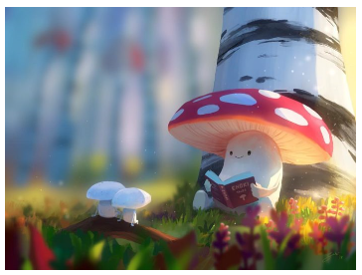

Look at the picture above and try and answer these questions. Remember to write in full sentences and use your imagination. You should be able to type your answers straight into the document, use a different colour font and then send the document back to me.
- What’s happening here?

- Do the two smaller mushrooms know the larger one?

- Have they done this before? How do you know?

- What might the larger mushroom be reading?

- What could the book be about?

