
QRA
Home School Agreement
September 2025
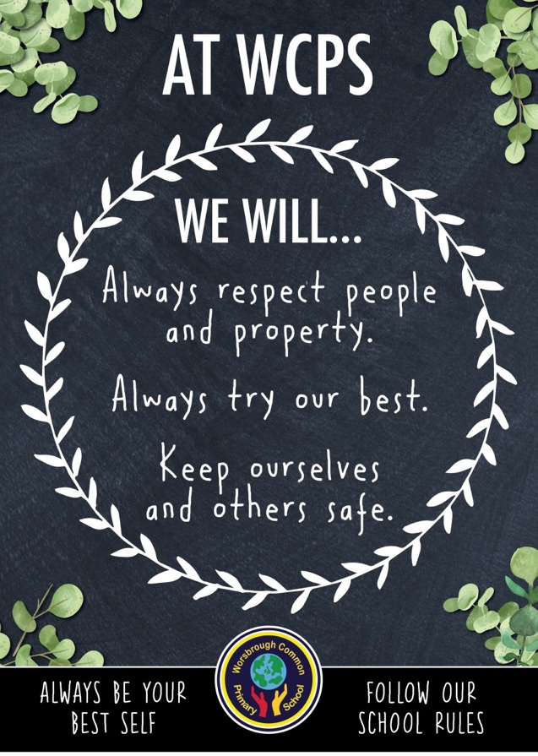

At QRA, we believe that children make the best progress when home and school work together. This agreement sets out the responsibilities of home and school in order to strengthen that relationship.
The school will always sign and abide by the agreement, we expect all parents/carers to sign the agreement indicating the support of the school’s expectations.

As a school we will aim to:
- Provide a safe, secure and stimulating learning environment in which your child will achieve their potential and take pride in their achievements.
- Encourage children to do their best at all times and provide a foundation for life-long learning.
- Develop in each child positive values and a caring attitude towards the school community and the environment.
- Develop positive and professional relationships with you and your child.
- Have a clear and consistent approach to rewards and sanctions for children as set out in the school’s Behaviour Policy.
- Provide a broad and balanced curriculum and meet the individual needs of every child.
- Communicate with parent/carers, as and when it is necessary, to share any concerns and ensure you are aware of the appropriate procedures.
- Promote parent/carer involvement and keep you informed about school matters.
- Send home an annual progress report and give appropriate time for you to respond.
- Do our best to achieve the school aims and ethos as contained in the School Prospectus.

As a parent/carer I aim to:
- Ensure that my child attends school regularly, arrives on time and is collected promptly.
- Contact the school by telephone on the first day of my child’s absence and keep school informed regularly of any prolonged absence.
- Provide my child with the correct uniform, PE kit and a water bottle.
- Inform the school of any concerns or problems that may affect my child’s school work or behaviour and do so in a responsible manner.
- Support all staff in their efforts to create a caring community which values children.
- Support the school’s expectations, values, and policies.
- Encourage my child in their learning and offer appropriate support at home.
- Encourage my child to become independent and take responsibility for their actions.
- Ensure time is made available for my child to complete home learning tasks, which are set to reinforce their understanding of the work being done in school.
- Attend parent-teacher meetings and discussions about my child’s progress in all aspects of school life.

As a parent/carer I have discussed the following with my child who will aim to:
- Move in an orderly manner around school.
- Show respect for people – be polite and caring.
- Show respect for property – look after things.
- Demonstrate appropriate levels of concentration and self-discipline – allow others to work without disturbing them.
- Take responsibility for their own actions and try to control their feelings – work consistently, always giving their best.
- Cooperate with others – take turns, share and listen and respond to the teacher’s voice and team stop signal.
- Be polite, considerate and caring – to adults and children.
- Set themselves goals and work hard to achieve them.

Headteacher Signature
Date | September 2025

Parent/Carer Signature

Parent/Carer of

Date

