
WCPS
Calculation Policy
Version Number | Version Description | Date of Revision
1 | Original | Sept 2023
2 | Rebranded & reviewed | July 2024
3 | Adopted by QRA on transfer to HCAT | August 2025

QRA Whole School Calculation Policy

Background
This policy contains the key pencil and paper procedures that will be taught within our school. It has been written to ensure consistency and progression throughout the school and reflects a whole school agreement. At WCPS we promote the linking of skills to ensure that tasks have context and calculations are part of real-life situations, are meaningful and learning is engaging and interesting.
Although the focus of the policy is on pencil and paper procedures it is important to recognise that the ability to calculate mentally lies at the heart of Mathematics. Mental methods for teaching mathematics will be taught systematically from Foundation Stage onwards and pupils will be given regular opportunities to develop the necessary skills. However mental calculation is not at the exclusion of written recording and should be seen as complementary to and not as separate from it.
In every written method there is an element of mental processing. Sharing written methods with the teacher encourages children to think about the mental strategies that underpin them and to develop new ideas. Therefore, written recording both helps children to clarify their thinking and supports and extends the development of more fluent and sophisticated mental strategies.
During their time at this school children will be encouraged to see mathematics as both a written and spoken language. Teachers will support and guide children through the following important stages:
- Developing the use of pictures and a mixture of words and symbols to represent numerical activities.
- Using standard symbols and conventions.
- Use of jottings to aid a mental strategy.
- Use of pencil and paper procedures.
This policy concentrates on the introduction of standard symbols, the use of the empty number line as a jotting to aid mental calculation and on the introduction of pencil and paper procedures. It is important that children do not abandon jottings and mental methods once pencil and paper procedures are introduced. Therefore, children will always be encouraged to look at a calculation/problem and then decide the best method to choose – pictures, mental calculation, with or without jottings. Our long-term aim is for children to be able to select an efficient method that is appropriate for a given task.
They will do this by always asking themselves:
- ‘Can I do this in my head?
- ‘Can I do this in my head using drawings or jottings?’
- ‘Do I need to use a pencil and paper procedure?’

Times tables
This policy also addresses the teaching of times tables.
FS and Y1 will focus on the development of number patterns and repeated addition
Y2 pupils will be taught 2, 5 and 10 times tables, with the more able also covering 3 times tables
Y3 will continue to work on 2, 5 and 10 times tables and also 3, 4, 8, 12 and 9’s
Y4 pupils should know all the times tables – they will need regular practise opportunities and should be able to mix times tables confidently.
Y5 and 6 pupils will continue to rehearse and develop their times table skills using larger numbers and decimals.
Please use your discretion regarding SEN pupils and test accordingly.
Year group labels are not exclusive, higher attaining pupils will be challenged, accessing higher year groups as appropriate. Similarly, pupils who are struggling should be challenged appropriately.
The testing of timestables will be completed termly to assess progress and highlight areas for development and support. We have a range of apps and websites that encourage practise both at school and at home. The weekly homework club will push the use of these to support learning.
Y3 and Y4 track pupils weekly soundcheck scores on the excel document (Arbor) so average scores and % can be worked out through the year. Y4 will sit the official MTC in the Summer Term.

Calculation across school
EYFS - Addition and Subtraction.
Simple number rhymes, songs and stories are an essential element to introduce simple mathematical concepts and language in this area.
In EYFS children are encouraged to make collections of objects or sets. Children are encouraged to count objects carefully touching each object, saying one number name for each object.
Addition is introduced by adding one more to a group or collection then recounting to find the total. Subtraction is introduced by taking away one from a group or collection and recounting to find how many are left.
As children become more confident with this simple number lines are introduced to encourage counting on or back. Children are encouraged to jump along, move an object or finger on the number line, going forwards to count on and backwards to count back.

Addition
Year 1 | Year 2 | Year 3
+ = signs and missing numbers  Add 1 and 2 digit numbers to 20  3 + 4 = □ □ = 3 + 4 13 + 4 = □ □ = 13 + 4  3 + □ = 7 7 = □ + 4 13 + □ = 20 20 = □ + 4  □ + 4 = 7 7 = 3 + □ 3 + □ = 17 17 = □ + 4  □ + ∇ = 7 7 = □ + ∇  Promoting covering up of operations and numbers.    Number lines (numbered)  7 + 4  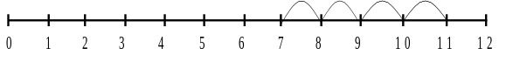  Recording by - drawing jumps on prepared lines  - constructing own lines  (Teacher model number lines with missing numbers)  (Teachers model jottings appropriate for larger numbers)  Using concrete objects and pictorial representations to solve simple one-step problems.  100 squares  We also make ongoing use of 100 squares to help children understand place value and to strengthen their grasp of numbers and the number system. 100 squares are used to practise counting on, finding numbers, talking about numbers and for those pupils who are ready adding 10 etc. This is extended into Year 2 to develop adding 19, 20, 9, 11 etc and subtracting 10, 20, 9 19, 11, 21 etc | + = signs and missing numbers  Continue using a range of calculations as in Year 1 but with appropriate, larger numbers up to 100.    84 + 5 = 10 + □  and adding three numbers  32 + □ + □ = 100 35 = 1 + □ + 5  Add 9 or 11 by adding 10 and adjusting by 1  35 + 9 = 44  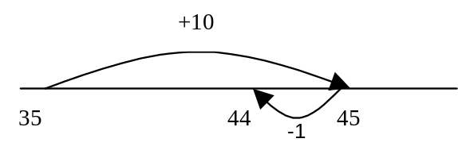  Development of confident partitioning and re-combining  23 = 20+3  147 = 100+40+7  200+50+9 recombines to 259    Partition into tens and ones and recombine remembering to add the units first then the 10’S  12 + 23 = 10 + 2  + 20 + 3  30 + 5 = 35  Move onto simple formal column addition by end of Y2 with more able carrying tens. (see y3).    $\begin{matrix} & 5_{} & 3_{} \\ + & 4_{} & 2_{} \\ {}_{} & 9_{} & 5_{}\end{matrix}$ $\begin{matrix} & 8_{} & 3_{} \\ + & 4_{} & 2_{} \\ 1_{} & 2_{} & 5_{}\end{matrix}$ | Continue using a range of equations with appropriate, larger numbers up to 1000.  Add a near multiple of 10 to a two-digit number  Continue as in Year 2 but with appropriate numbers  e.g. 35 + 19 is the same as 35 + 20 – 1.  Efficient written method (Formal method) carrying tens and hundreds  683 + 442 = 1125  $\begin{matrix} & {}_{}^{}{} & {}_{}^{}6 & {}_{}^{}8 & {}_{}^{}3 \\ + & {}_{1}^{}{} & {}_{1}^{}4 & {}_{}^{}4 & {}_{}^{}2 \\ & {}_{}^{}1 & {}_{}^{}1 & {}_{}^{}2 & {}_{}^{}5\end{matrix}$  Moving on to using column addition in varying contexts. Applying these strategies to solve worded problems.  £683 + £442 = £1125  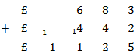  Pupils can use estimates and inverse checks.  683 + 442 = 1125  Estimate:  700+400=1100    Inverse:  $$\begin{matrix} & {}_{}^{0}1 & {}_{}^{10}1 & {}_{}^{1}2 & {}_{}^{}5 \\ - & {}_{1}^{}{} & {}_{1}^{}4 & {}_{}^{}4 & {}_{}^{}2 \\ & {}_{}^{}{} & {}_{}^{}6 & {}_{}^{}8 & {}_{}^{}3\end{matrix}$$
Addition
Year 4 | Year 5 | Year 6
Continue using a range of equations with appropriate numbers, up to 4 digits and including decimals.  Confidently and efficiently using formal methods of column addition with increasingly large numbers and as part of two-step problems.  5827+7809=13636  $\begin{matrix} & {}_{}^{}{} & {}_{}^{}5 & {}_{}^{}8 & {}_{}^{}2 & {}_{}^{}7 \\ + & {}_{1}^{}{} & {}_{1}^{}7 & {}_{}^{}8 & {}_{1}^{}0 & {}_{}^{}9 \\ & {}_{}^{}1 & {}_{}^{}3 & {}_{}^{}6 & {}_{}^{}3 & {}_{}^{}6\end{matrix}$  (Pupils appropriately display their final answer.)  Extending context to include decimals.  £ 58.27 + £ 78.09 = £ 136.36  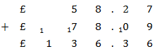  (Children should be using column methods as part of their chosen methods.)  Estimating and inverse checking should be a regular part of each pupils own calculation process.  5827+7809=13636  Estimate:  5800+7800=13600  Inverse:  $\begin{matrix} & {}_{}^{0}1 & {}_{}^{12}3 & {}_{}^{1}6 & {}_{}^{2}3 & {}_{}^{1}6 \\ - & {}_{}^{}{} & {}_{}^{}7 & {}_{}^{}8 & {}_{}^{}0 & {}_{}^{}9 \\ & {}_{}^{}{} & {}_{}^{}5 & {}_{}^{}8 & {}_{}^{}2 & {}_{}^{}7\end{matrix}$ | Continue using a range of equations with appropriate numbers, with more than 4 digits and including decimal.  Mental methods are used with increasingly large numbers, developing fluency. (e.g. 10,162 + 2300 = 12,462)  As part of the mental process children continue to partition as required.  10,000+2000=12000  162+300=462  12000+462=12462  Pupils apply formal column addition, accurately, as part of multi-step problems using multiple numbers with more than 4 digits and decimals.  Formal method shows numbers carried clearly and use of place holders known to not be crucial but aids accuracy.  916.95 + 78.3 + 36.36 = 1031.61  $\begin{matrix} & & {}_{}^{}9 & {}_{}^{}1 & {}_{}^{}6 & .{}_{}^{}9 & {}_{}^{}5 \\ + & & {}_{}^{}{} & {}_{}^{}7 & {}_{}^{}8 & .{}_{}^{}3 & {}_{}^{}{} \\ & {}_{1}^{}{} & {}_{1}^{}{} & {}_{2}^{}3 & {}_{1}^{}6 & .{}_{1}^{}3 & {}_{}^{}6 \\ & {}_{}^{}1 & {}_{}^{}0 & {}_{}^{}3 & {}_{}^{}1 & .{}_{}^{}6 & {}_{}^{}1\end{matrix}$  Estimating and inverse checking should be a regular part of each pupils own calculation process.  (Pupils should make use of rounding to estimate and know it provides different levels of accuracy.) | Continue using a range of equations with appropriate numbers, with more than 4 digits and including decimal.  Mental methods – continue to use with multi-step problem - as year five, using increasingly difficult numbers.  Add the nearest multiple of 10, 100 or 1000, then adjust  with appropriate numbers including extending to adding 0.9, 1.9, 2.9 etc  Efficient written method  Extend to numbers with any number of digits and decimals going beyond 2 decimal places. Applying as part of multi-step word problems.  916.95 + 78.3 + 36.36 = 1031.61  $\begin{matrix} & & {}_{}^{}9 & {}_{}^{}1 & {}_{}^{}6 & .{}_{}^{}9 & {}_{}^{}5 \\ + & & {}_{}^{}{} & {}_{}^{}7 & {}_{}^{}8 & .{}_{}^{}3 & {}_{}^{}{} \\ & {}_{1}^{}{} & {}_{1}^{}{} & {}_{2}^{}3 & {}_{1}^{}6 & .{}_{1}^{}3 & {}_{}^{}6 \\ & {}_{}^{}1 & {}_{}^{}0 & {}_{}^{}3 & {}_{}^{}1 & .{}_{}^{}6 & {}_{}^{}1\end{matrix}$  Unit of measure (ensure same unit)  1.6km + 850m  1600m + 850m  Then add as above.  Pupils targeted to attain GDS will be expected to use and apply the year 6 methods in a variety of contexts.  Estimating and inverse checking should be a regular part of each pupils own calculation process.
Subtraction
Year 1 | Year 2 | Year 3
Pictures / marks  Sam spent 4p. What was his change from 10p?  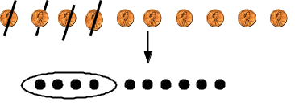  - = signs and missing numbers  7 - 3 = □ □ = 7 - 3  7 - □ = 4 4 = □ - 3  □ - 3 = 4 4 = 7 - □  □ - ∇ = 4 4 = □ - ∇    Number lines (numbered)  11 – 7  (Counting back)    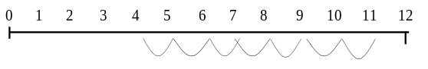  The difference between 7 and 11  (Counting up)  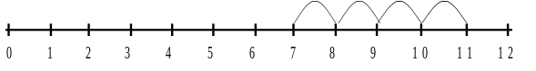  Recording by - drawing jumps on prepared lines  - constructing own lines  (Teachers model jottings appropriate for larger numbers) | - = signs and missing numbers  Continue using a range of calculations as in Year 1 but with appropriate numbers.    Extend to 14 + 5 = 20 - □  Find a small difference by counting up  42 – 39 = 3  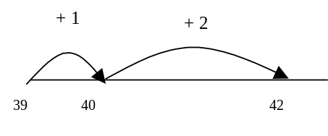  Subtract 9 or 11. Begin to add/subtract 19 or 21  35 – 9 = 26  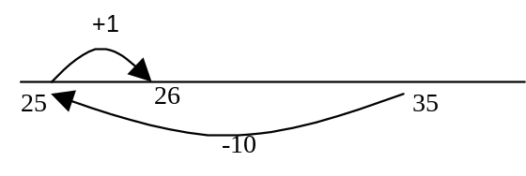    Use known number facts and place value to subtract (partition second number only)  37 – 12 = 37 – 10 – 2  = 27 – 2  = 25  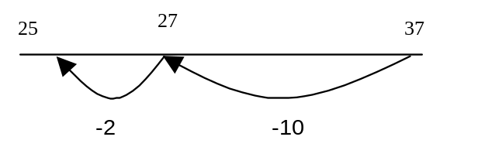    Towards the end of year 2 introduce column subtraction (without exchanging) using numbers up to 100.  $\begin{matrix} & 9_{} & 7_{} \\ - & 4_{} & 2_{} \\ {}_{} & 5_{} & 5_{}\end{matrix}$ | Continue using a range of equations using appropriate numbers, progressing towards 3 digits.  Find a small difference by counting up  Continue as in Year 2 but with appropriate numbers e.g. 102 – 97 = 5  Subtract mentally a ‘near multiple of 10’ to or from a two-digit number  Continue as in Year 2 but with appropriate numbers e.g. 78 – 49 is the same as 78 – 50 + 1  Continue with column subtraction with numbers up to 100, introducing exchanging. Moving on to 3 digit subtraction when ready.    $\begin{matrix} & {}_{}^{}{} & {}_{}^{6}7 & {}_{}^{1}2 & {}_{}^{}5 \\ & {}_{}^{}- & {}_{}^{}4 & {}_{}^{}4 & {}_{}^{}2 \\ & {}_{}^{}{} & {}_{}^{}2 & {}_{}^{}8 & {}_{}^{}3\end{matrix}$  Pupils can use estimates and inverse checks.  725 - 442 = 283  Estimate:  700-400=300  Inverse:  283 + 442 = 725  $$\begin{matrix} & {}_{}^{}{} & {}_{}^{}2 & {}_{}^{}8 & {}_{}^{}3 \\ & {}_{}^{}+ & {}_{1}^{}4 & {}_{}^{}4 & {}_{}^{}2 \\ & {}_{}^{}{} & {}_{}^{}7 & {}_{}^{}2 & {}_{}^{}5\end{matrix}$$
Subtraction
Year 4 | Year 5 | Year 6
Continue using a range of equations with appropriate numbers, progressing towards 4 digit numbers  Use mental process to find smaller subtraction problems when column subtraction isn’t necessary.  Find a small difference by counting up or partitioning.  e.g. 5003 – 4996 = 7  Subtract the nearest multiple of 10, then adjust.  Continue with column subtraction with numbers up to 10000, consolidating exchanging with multiple digits. Moving on to 4 digit subtraction when ready.  5281-2442=2839  $\begin{matrix} & {}_{}^{4}5 & {}_{}^{1}2 & {}_{}^{7}8 & {}_{}^{1}1 \\ - & {}_{}^{}2 & {}_{}^{}4 & {}_{}^{}4 & {}_{}^{}2 \\ & {}_{}^{}2 & {}_{}^{}8 & {}_{}^{}3 & {}_{}^{}9\end{matrix}$  Extending context to include decimals.  £52.81 - £24.42 = £28.39  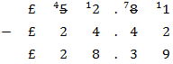  Estimating and inverse checking should be a regular part of each pupils own calculation process. | Continue using a range of equations with appropriate numbers, progressing beyond 4 digit numbers and multiple decimal places.  Mental subtraction methods are used with increasingly large numbers, developing fluency. (e.g. 12,462 - 2300 = 10,162)  As part of the mental process children continue to partition as required.  12,462-2000=10462  10462-300=10162  Column Subtraction  Making use of column subtraction in multi-step problems in a variety of contexts. Numbers beyond 4 digits with multiple decimals.  Examples of numbers with different decimal places (as in addition). Decimal points should line up under each other. Emphasis on use of place holders to ensure accuracy.  646.42 – 94.7 = 651.72  $\begin{matrix} & & {}_{}^{5}6 & {}_{}^{1}4 & {}_{}^{5}6 & .{}_{}^{1}4 & {}_{}^{}2 \\ & - & {}_{}^{}0 & {}_{}^{}9 & {}_{}^{}4 & .{}_{}^{}7 & {}_{}^{}0 \\ & & {}_{}^{}6 & {}_{}^{}5 & {}_{}^{}1 & .{}_{}^{}7 & {}_{}^{}2\end{matrix}$  Estimating and inverse checking should be a regular part of each pupils own calculation process.  (Pupils should make use of rounding to estimate and know it provides different levels of accuracy.) | Continue using a range of equations with appropriate numbers, progressing beyond 4 digit numbers and multiple decimal places. Pupils choose appropriate operation to solve the problem.  Pupils will be expected to confidently use and apply the column subtraction methods in a variety of contexts. As part of a chain of different operations.  34.9 - 9.488 = 25.412  $\begin{matrix}{}_{}^{}{} & {}_{}^{2}3 & {}_{}^{1}4 & .{}_{}^{8}9 & {}_{}^{9 1}0 & {}_{}^{1}0 \\ {}_{}^{}- & {}_{}^{}{} & {}_{}^{}9 & .{}_{}^{}4 & {}_{}^{ }8 & {}_{}^{}8 \\ & {}_{}^{}2 & {}_{}^{}5 & .{}_{}^{}4 & {}_{}^{}1 & 2\end{matrix}$  Formal method shows numbers exchanged clearly and use of place holders known to not be crucial but aids accuracy. Exchanging may occur over multiple columns.  Unit of measure (ensure same unit)  1.6km - 850m  1600m - 850m  Then subtract using efficient written method.  Estimating and inverse checking should be a regular part of each pupils own calculation process.
Multiplication
Year 1 | Year 2 | Year 3
Solve simple one step problems involving multiplication.  Use concrete objects to support understanding of repeated addition.  Calculating pictures and symbols.  There are 3 sweets in one bag.  How many sweets are there in 5 bags?    (Recording on a number line modelled by the teacher when solving problems)  Use of bead strings to model groups of.  Moving on to using arrays with teacher support.  -    4 x 2 or 4 + 4  -    2 x 4 | Solve one step multiplication problems in context.  Moving towards independent use arrays and repeated addition    -    4 x 2 or 4 + 4  -     2 x 4  or repeated addition  2 + 2 + 2 + 2  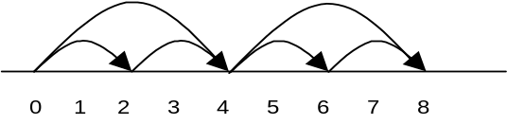  Doubling multiples of 5 up to 50  15 x 2 = 30  x = signs and missing numbers  7 x 2 = □ □ = 2 x 7  7 x □ = 14 14 = □ x 7  □ x 2 = 14 14 = 2 x □  □ x ∇ = 14 14 = □ x ∇  Recognise and use inverse relationships.  (2x3=6, 3x2=6, 6÷2=3, 6÷3=2)  Understanding multiplication of two numbers can be done in either order. Learn multiplication facts, with emphasis on 10, 5 and 2 times tables. Introduction of HCPS timetables card to encourage learning of tables. Including recognising odd and even numbers. Extend for more able. Calculate mathematical statements for within the multiplication tables and write them using the multiplication (×) and equals (=) signs.Children are encouraged to use jottings to help them solve problems; Eg There are 3 sweets in a box. Sam has 2 boxes. How many sweets does he have?  2 lots of 3 or 2x3 =6 | Continue using a range of equations with appropriate numbers.  Children continue using number lines until confident to begin moving on to more efficient formal methods.    Number lines  6 x 3  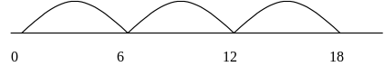  Continue to understand multiplication as repeated addition and continue to use arrays  Doubling multiples of 5 up to 50  35 x 2 = 70  Use known facts and place value to carry out simple multiplications.  Children advancing use and recall of multiplication tables, with emphasis on 3, 4 and 8 times tables. Continued use of HCPS timetables cards. Extend for more able.  Pupils progressing to the use of an efficient method of short multiplication    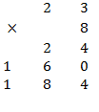  (3x8)  (20x8)  Children can use manipulation of place value to multiply by 10 and 100.  (To be taught as digits moving around the decimal point.)
Multiplication
Year 4 | Year 5 | Year 6
  Mental methods build on partitioning skills with larger more complex numbers and wider concepts.  eg 7 x 15 = 7 x 10 = 70  7 x 5 = 35  70+ 35 = 105  Children should be confident in applying pencil and paper procedures, making use of short multiplication.  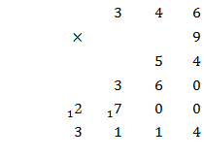    (9 x 6)  (9 x 40)  (9 x 300)  (Remember the number carried goes above the line)  When confident children are introduced to the more efficient long multiplication column methods. (Before moving on to this method children should secure with the place value involved.)    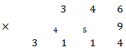  Children advancing use and recall of all multiplication tables, up to and including 12x12. (including 0 and 1) Continued use of HCPS timetables cards. Extend for more able with knowing all inverse and applying to worded problems and real life situations.  Children can use manipulation of place value to multiply by 10 and 100 and 1000. Understand relationship to inverse division.  (To be taught as digits moving around the decimal point.) |   Mental methods build on partitioning skills with larger more complex numbers and wider concepts.  eg 12 x 25 = 10 x 25 = 250.  2 x 25 = 50  250+ 50 = 300  (Discussion around different strategies and order of partitioning, children should understand they can apply their own strategies. E.g 12x20=240, 12x5=60,240+60=300)  (Remember the number carried goes above the line)  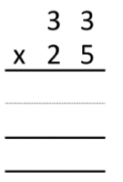  Once children are familiar and confident with these longer methods, they can progress to:    Children advance towards using their efficient long multiplication methods with 4 digit by 2 digit numbers.    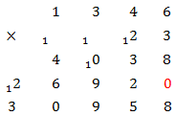  Children should be able to apply this to a variety of real life contexts.  (e.g. money and units of measure)  23 children went on the trip at £13.46 each. How much did it cost altogether?  £13.46 x 23 = £309.58  Estimating and inverse checking should be a regular part of each pupils own calculation process. | Continue with efficient written method using appropriate numbers.  Unit of measure (ensure same unit) as explained previously  Efficient written method  Extend to 5 digit by 2 digit, incorporating multiple decimals. Applying as part of multi-step word problems in real life context.  213.46 x 2.3 =    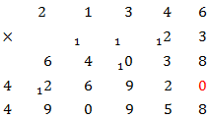  With this method, the original problem has been changed when entered into the column multiplication, from 213.46x2.3 to 21346x23(effectively multiplying your answer by 1000 as you have removed 3dp altogether). Children are taught that decimals can then be re-accounted for at the final answer stage. (count decimal places and apply)  490958 ÷ 1000 = 490.958  (A reasonable estimate, 215x2=430, 210x2.5=525, can validate the correct placement of the decimal)  Units of measure (ensure same unit)  When multiplying decimals, pupils estimate to ensure correct place value.  Estimating and inverse checking should be a regular part of each pupils own calculation process.
